Himley Hall
Framed Paintings, Canvases & Photography Exhibits

All pictures must be hung with two picture/mirror plates
Picture/Mirror Plate
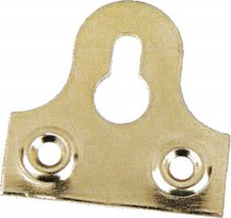
Make sure you place the plates one third of the way down the frame, this will allow the picture to be hung correctly.
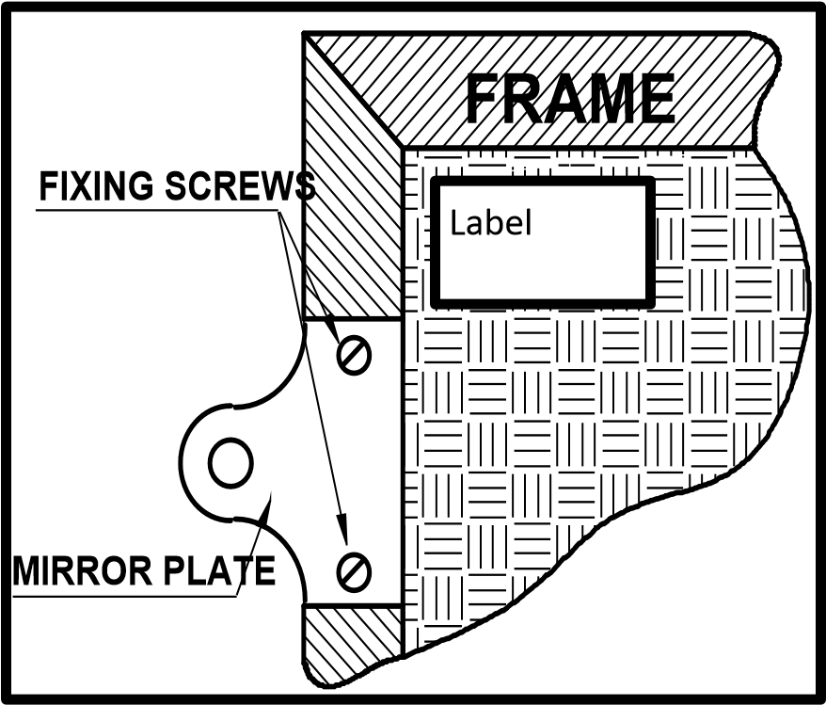
Ensure that the picture/mirror plates are attached prior to delivery for xhibition

Unframed canvases
All Canvases must also be hung with picture/mirror plates.

.

